NAME :M.NAVEEN KUMAR REDDY

REG.NO :192111719

COURSE :COMPUTER NETWORKS

CODE :CSA0719

FACULTY : DR.ANITHA.G

LAB MANUAL 11 TO 15

11.IOT Based Smart Home Using Cisco Packet Tracer

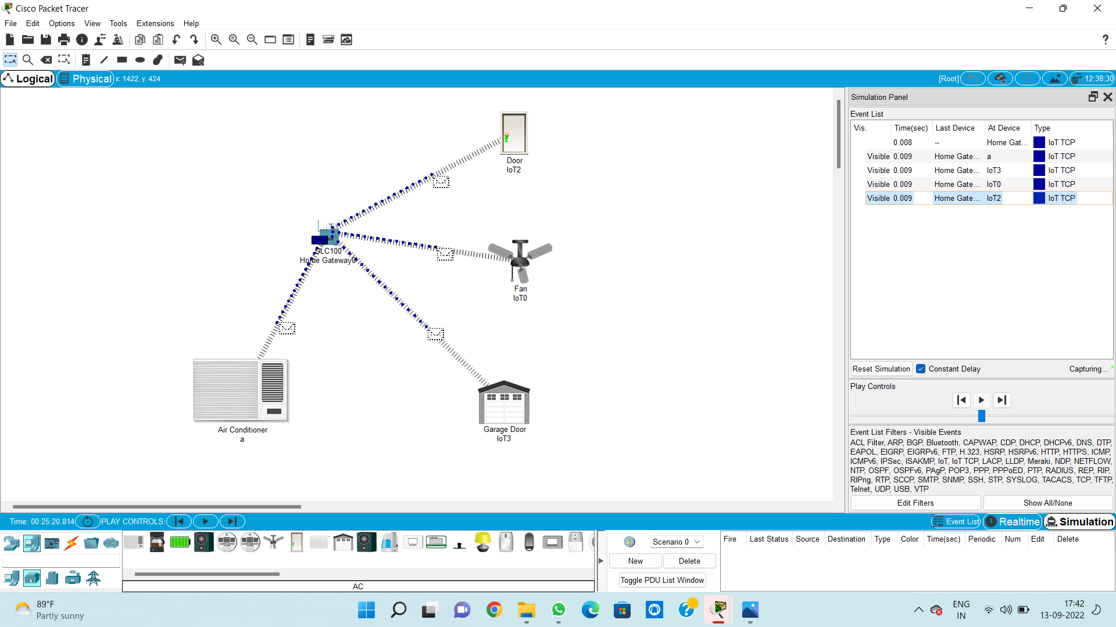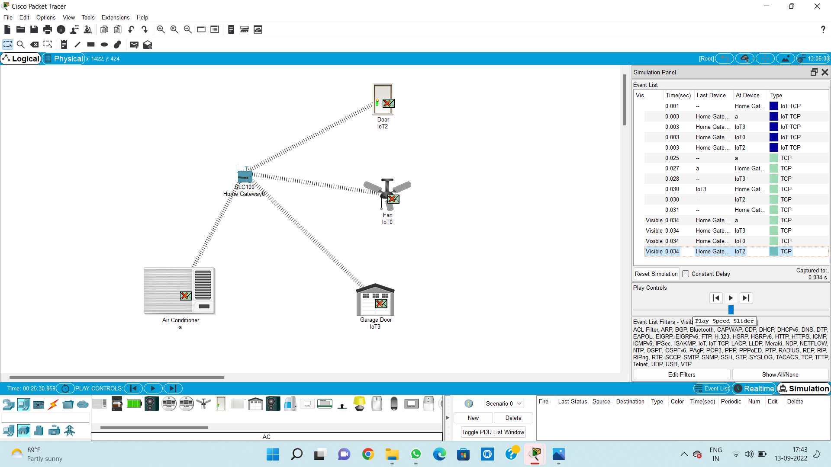

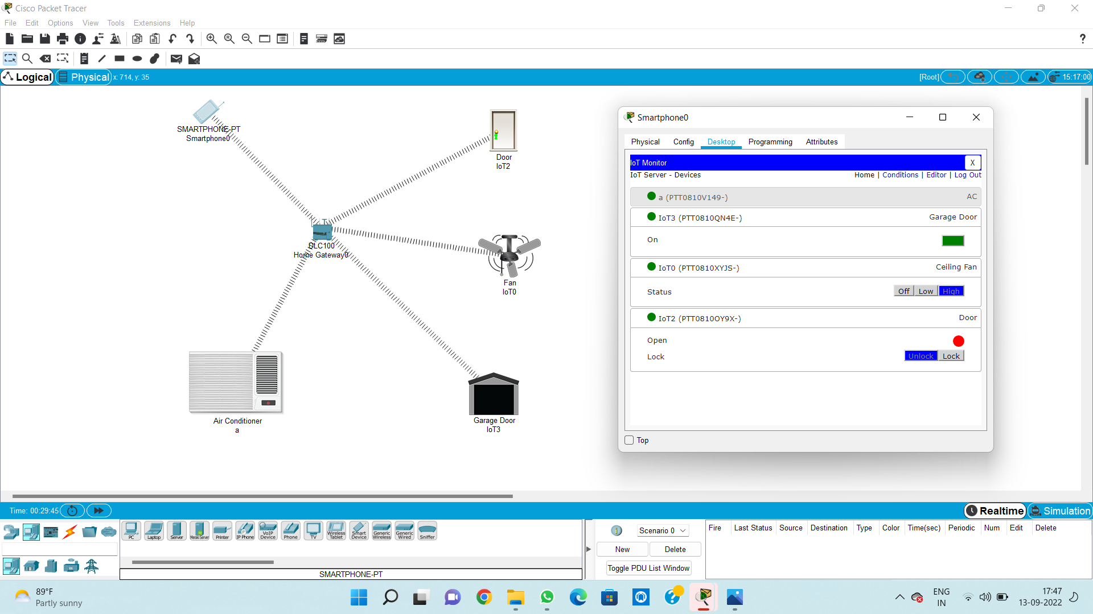

12. Smart Garden in Cisco Packet Tracer

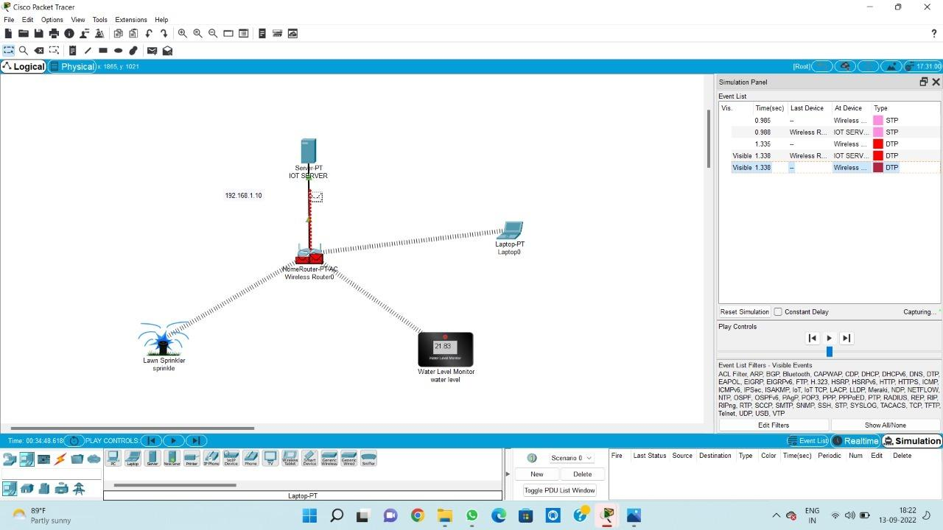



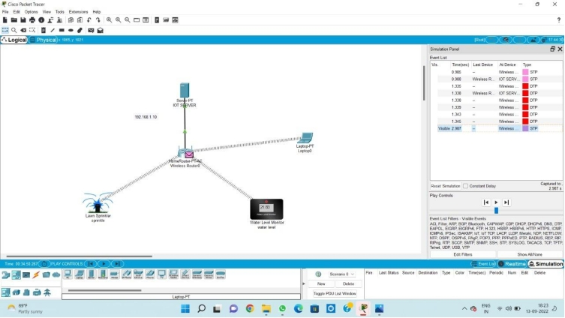

13.IOT Devices in Networking Using Cisco Packet Tracer

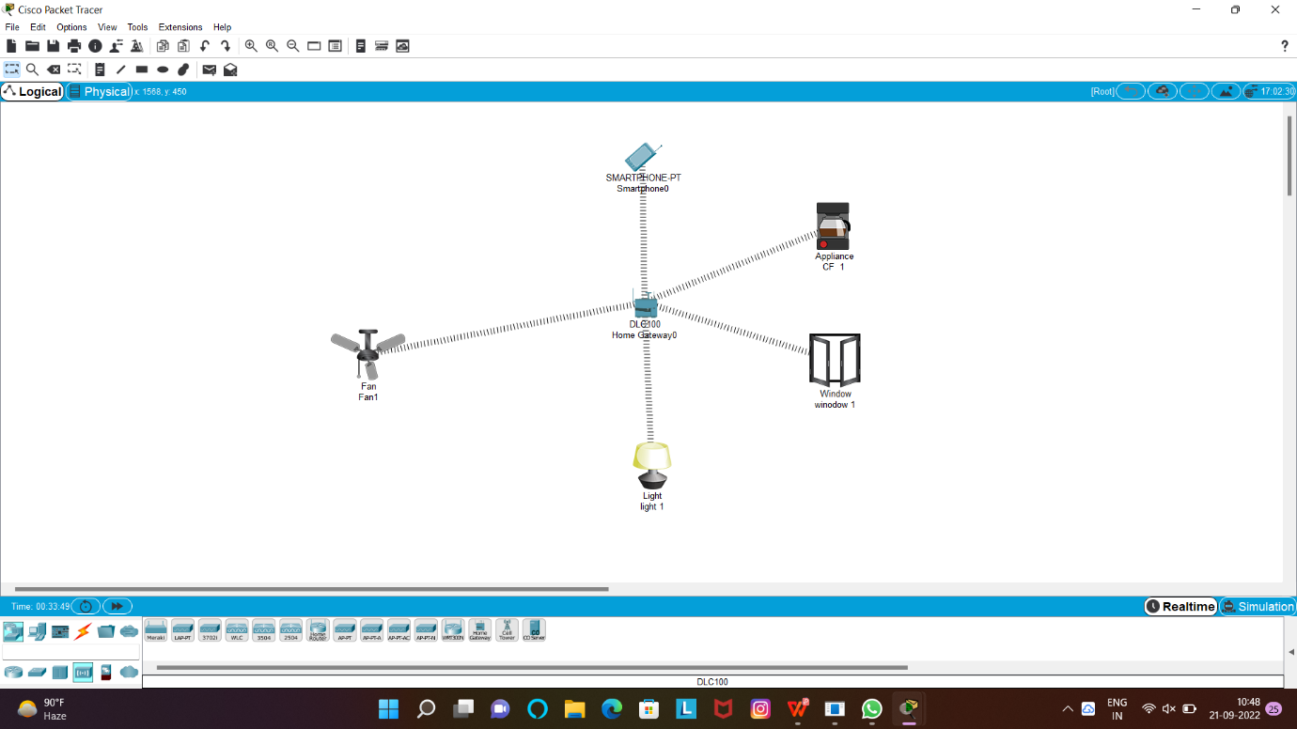

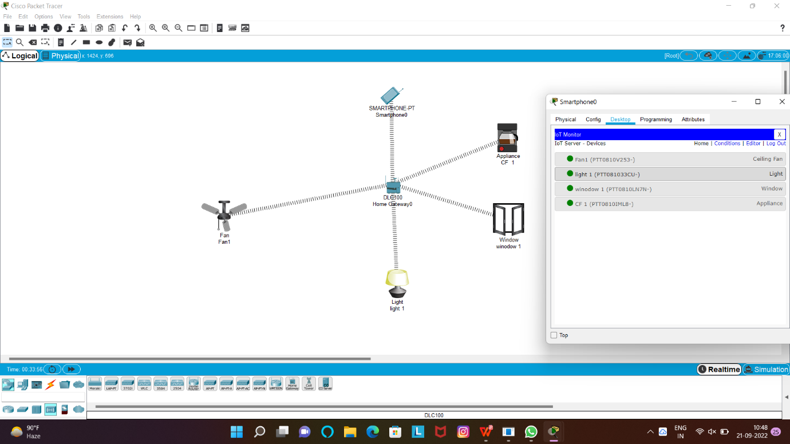

14.Simulating X,Y,Z Company Network Design

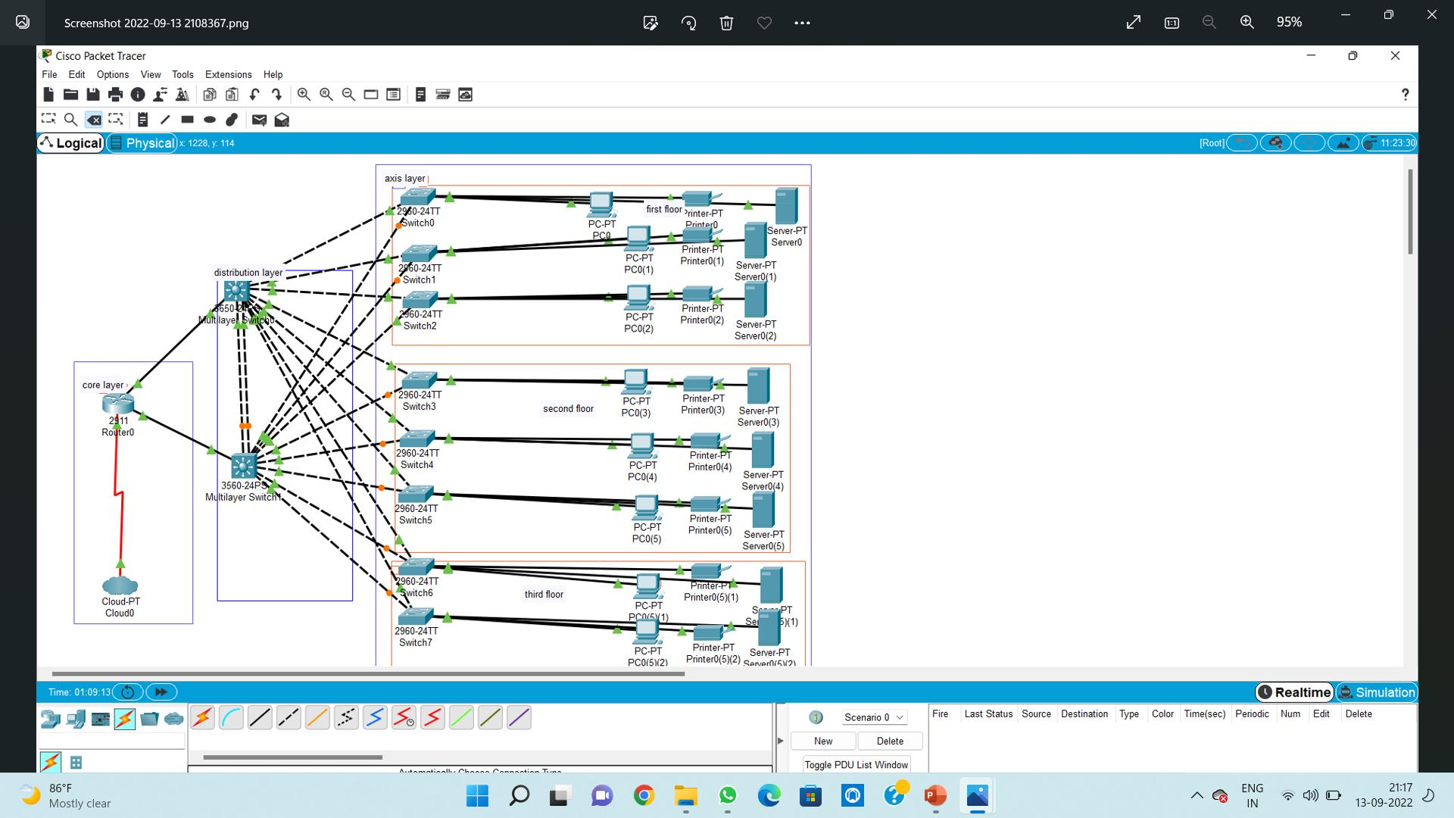

15.Make Computer Lab in Cisco Packet Tracer

